**Building AI Browser Agents**

**🌐 What are Web Agents?**

**Web agents are smart computer programs that can do things on websites by themselves, just like a human would.  
For example, a web agent can go to an online shop, search for a book, add it to the cart, and even place the order — all without any help from a person.**

**💼 Where Can We Use Them?**

**These agents are super useful for many tasks:**

* **Buying things online 🛒**
* **Filling out forms ✍️**
* **Collecting data from websites 📊**
* **Managing social media 💬**
* **Giving customer support 🤖**
* **Doing jobs in banking, healthcare, and more 🏦🏥**

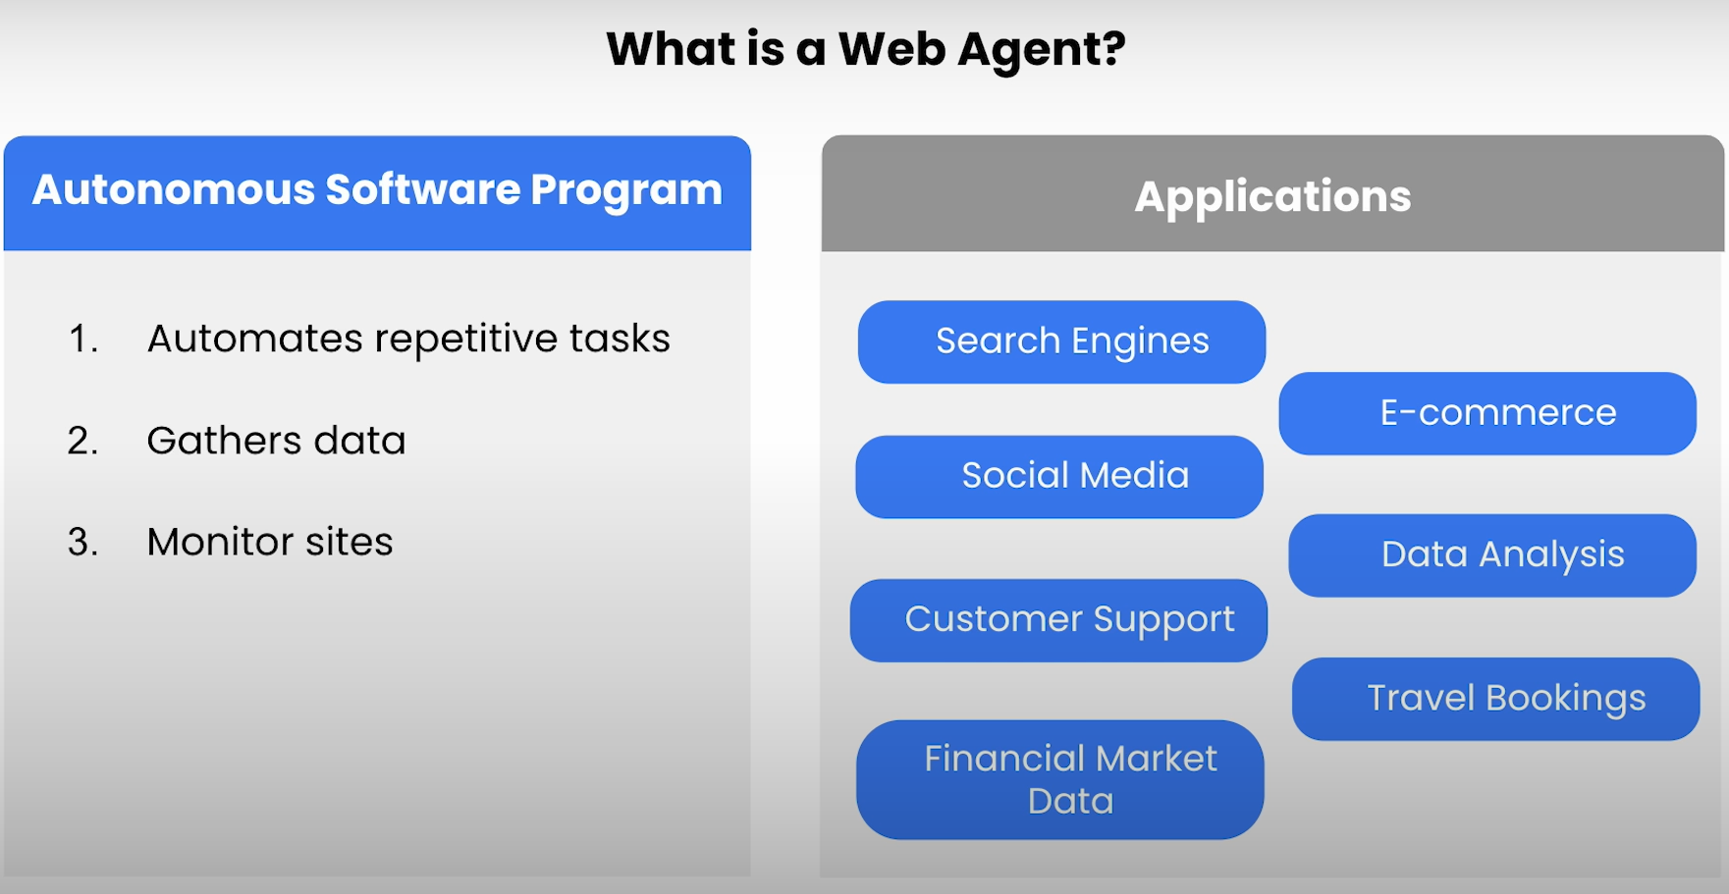

**🧠 How Do Web Agents Work?**

**They’re made up of different parts:**

1. **User Interface – You tell the agent what to do using simple language.**
2. **Control Module – This is the agent’s brain. It decides what needs to be done.**
3. **Knowledge Base – Stores facts and rules the agent needs to do the task.**
4. **Communication Module – Talks to the website or app.**
5. **Data Processing Module – Cleans and organizes the information it gets.**

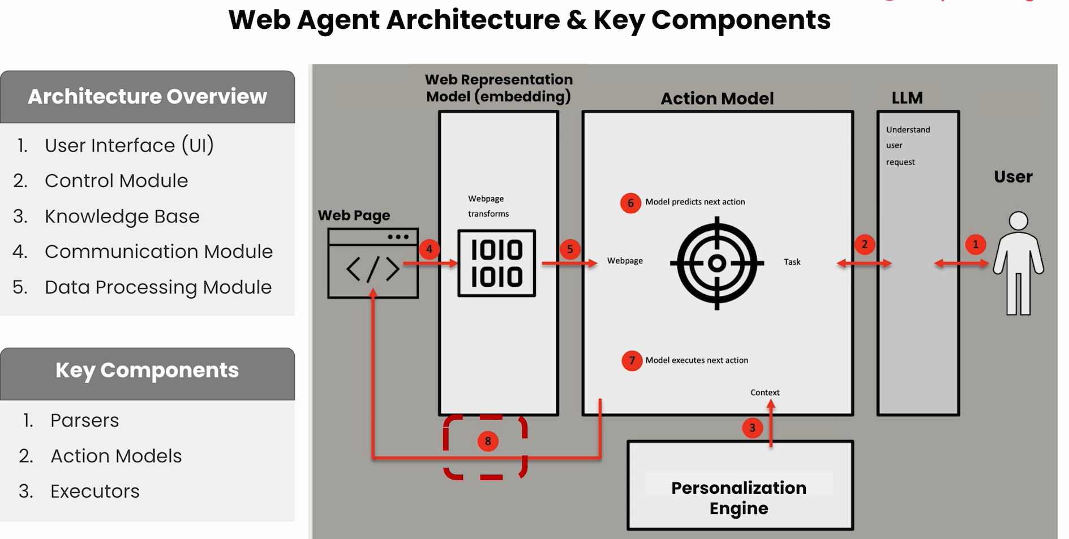

**🔁 How It All Happens:**

1. **You give a task (like “buy a red notebook”).**
2. **The agent understands the task.**
3. **It plans what to click or type on the website.**
4. **It does those steps one by one.**
5. **If needed, it repeats the process until the job is done.**

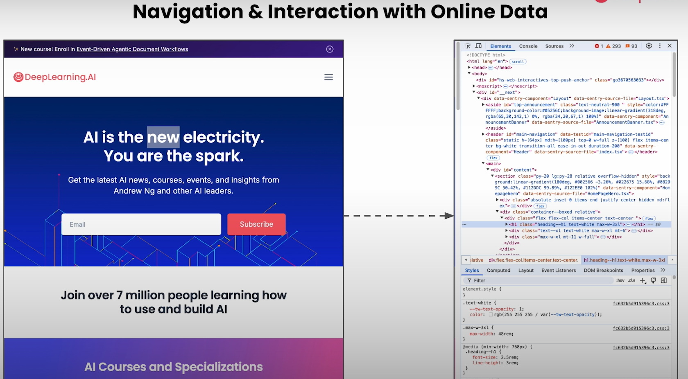

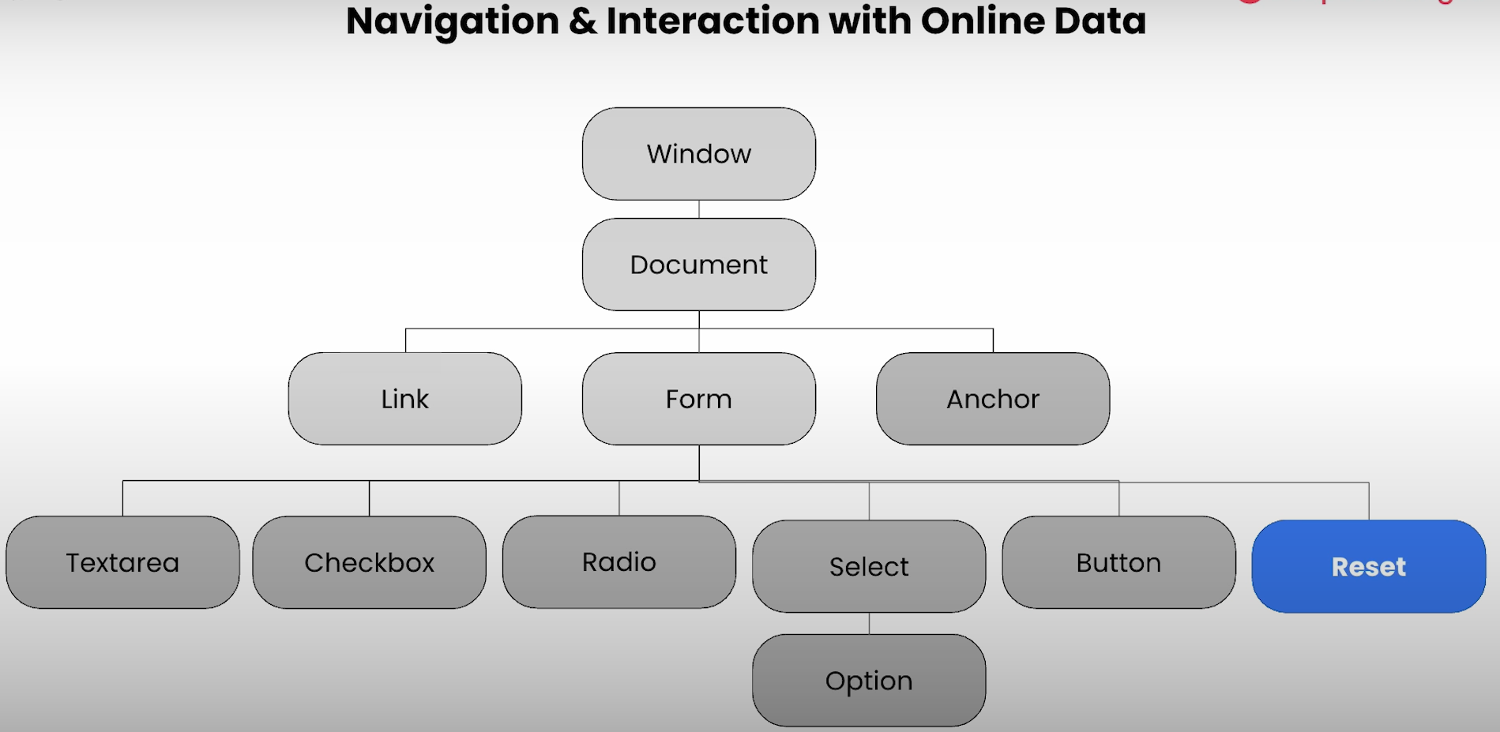

**⚠️ What Are the Challenges?**

* **Websites change often, so the agent might get confused.**
* **It needs to avoid mistakes.**
* **It should be able to think and adjust when things don’t go as expected.**

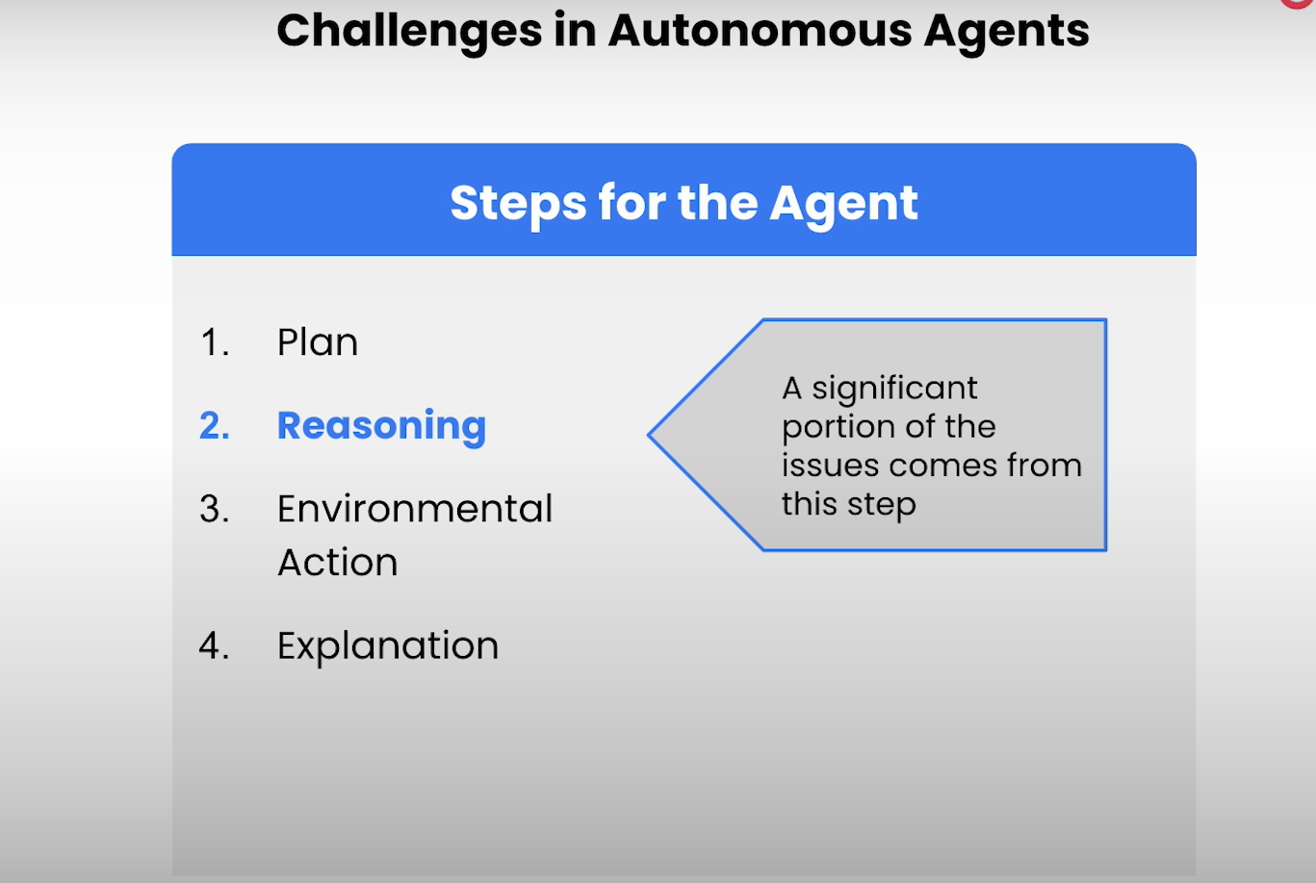

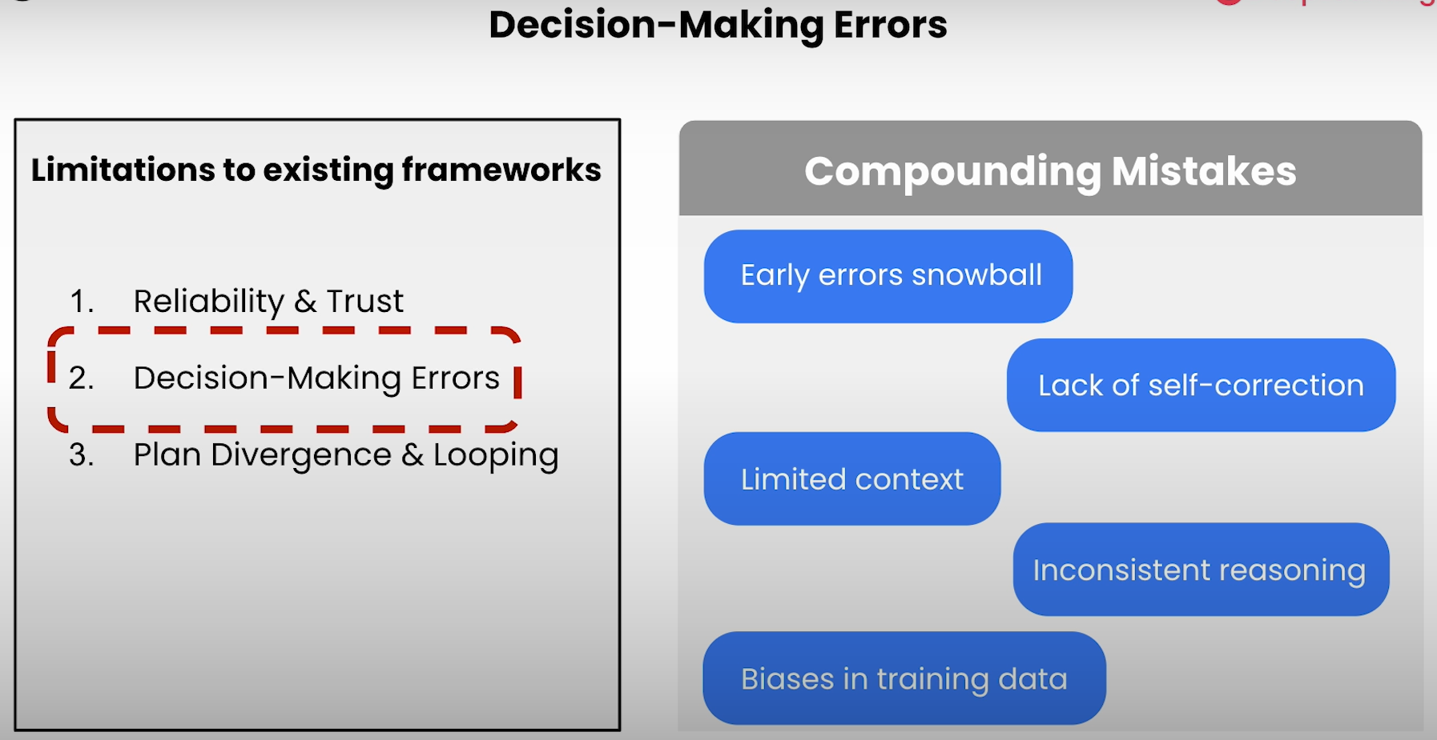

**🤖 Web Agents: Decision-Making Problems**

**When a web agent is trying to complete a task, it has to choose between two ways of working:**

**🔍 Exploration**

* **The agent tries new things it hasn’t done before.**
* **This might help it find better solutions, but…**
* **It can also waste time or make mistakes if it chooses a wrong or confusing path.**

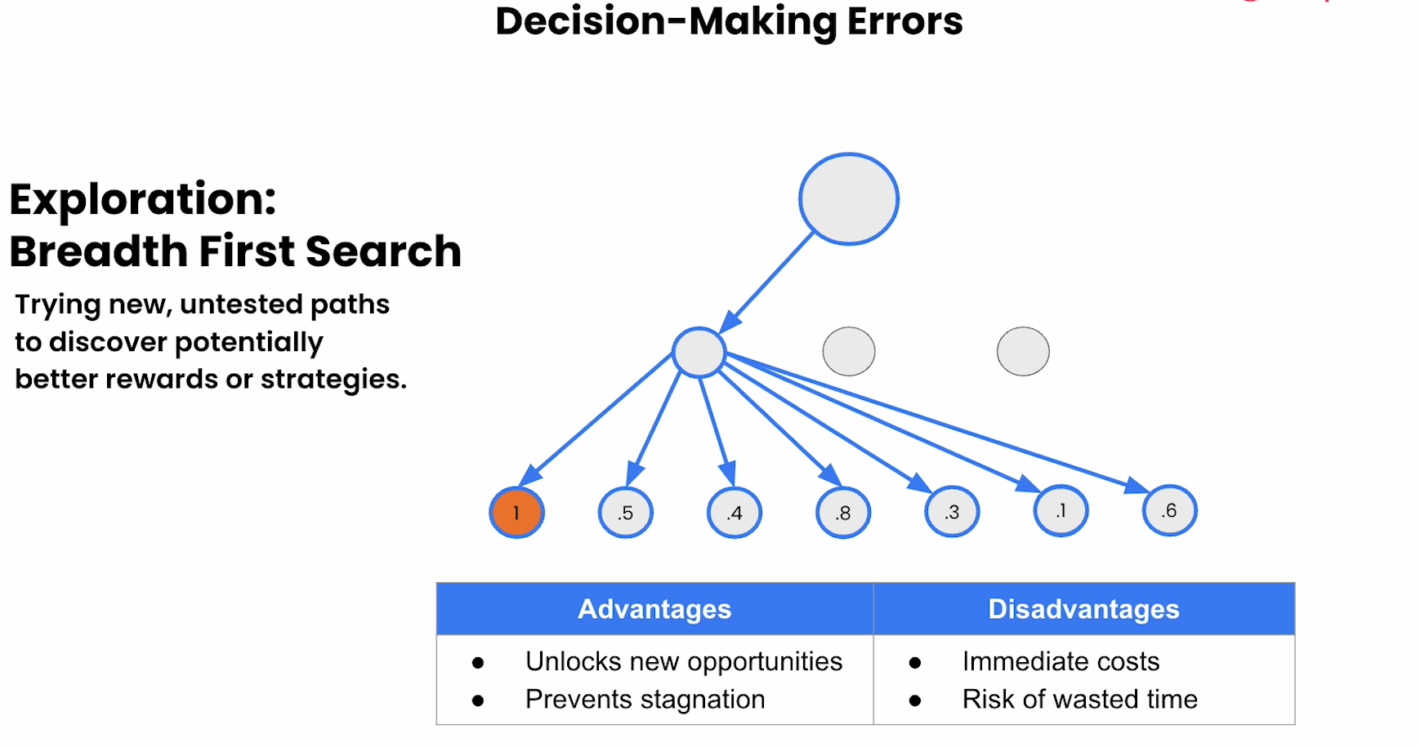

**✅ Exploitation**

* **The agent uses the same methods that worked well in the past.**
* **This is usually safe and fast, but…**
* **It might miss out on better or faster ways to do the job.**

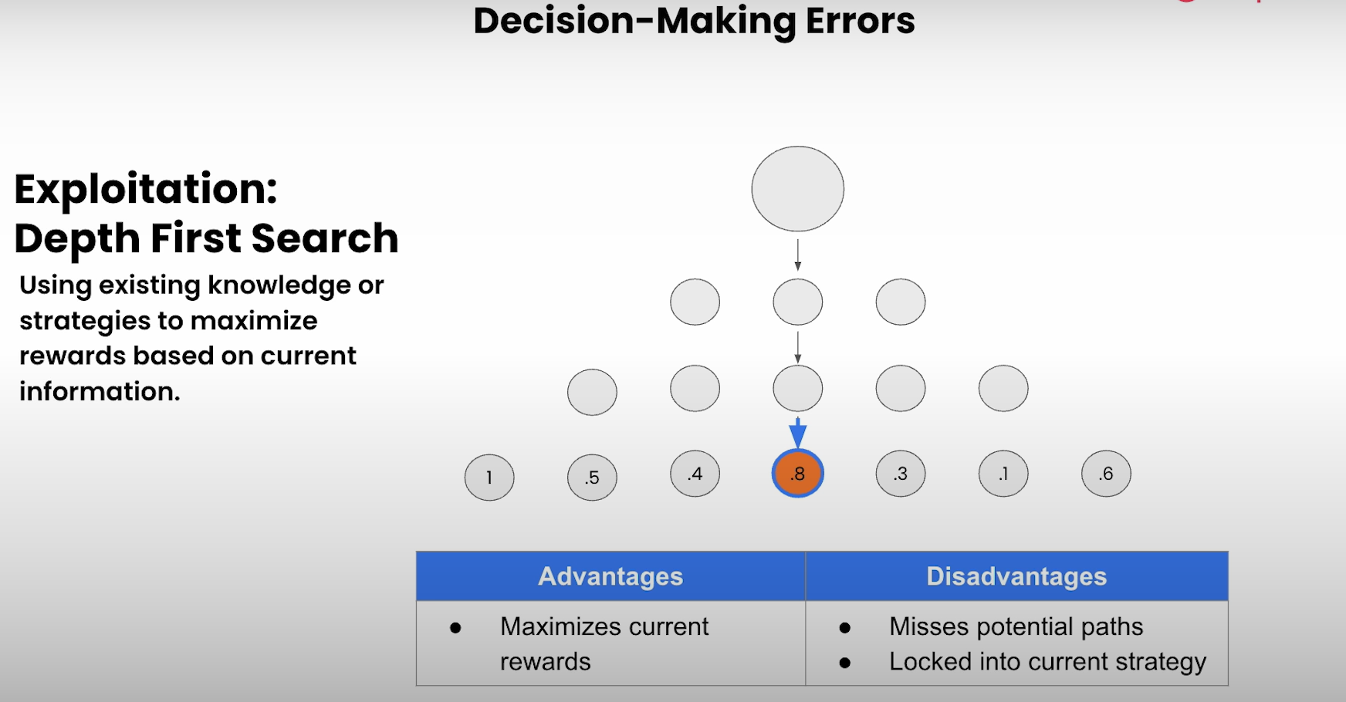

**⚠️ What Can Go Wrong?**

**If the agent explores too much, it might:**

* **Go in the wrong direction**
* **Take too long to finish the task**

**If it exploits too much, it might:**

* **Never discover smarter ways to work**
* **Keep doing an okay job instead of a great one**

**🔁 Other Problems:**

* **Plan Divergence: Agent starts doing something and then loses track of the goal.**
* **Looping: Agent keeps repeating the same steps without making progress.**

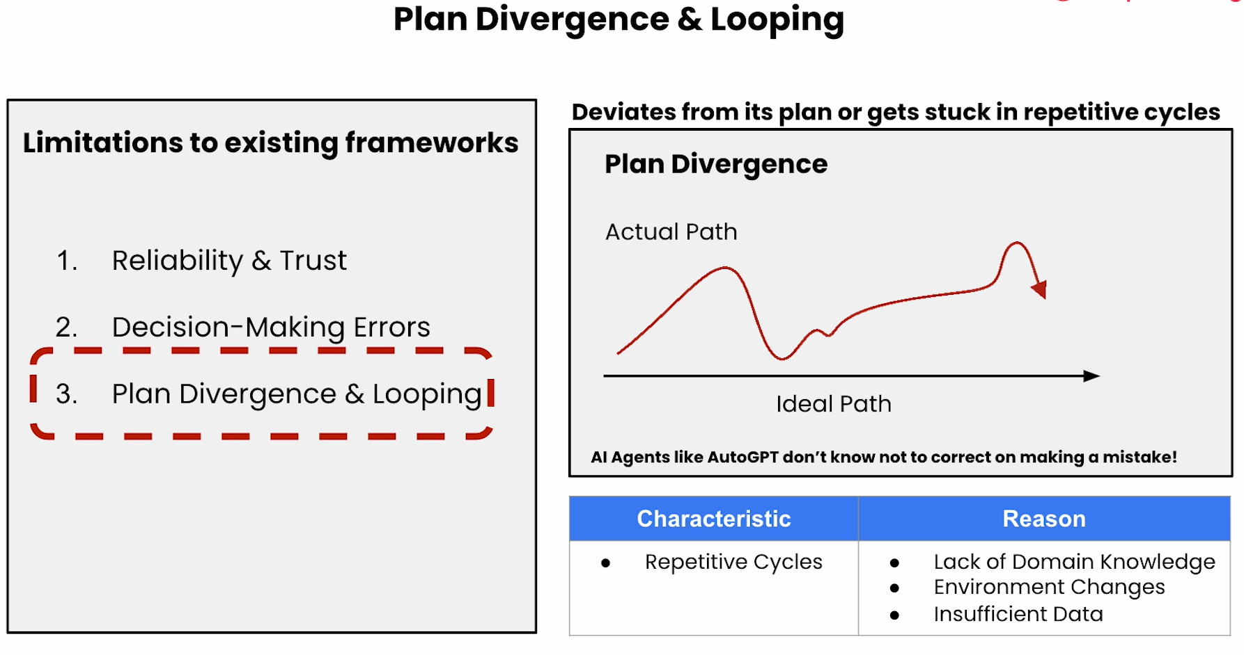

**🧠 How to Fix This?**

**The course talks about using smarter agents like Agent Q, which uses a technique called Monte Carlo Tree Search (MCTS).  
This helps the agent:**

* **Try different action paths in its mind**
* **Pick the best one based on what it *thinks* will happen**

**This way, the agent makes better choices and avoids wasting time or getting stuck.**

**Building a Simple Web Agent**

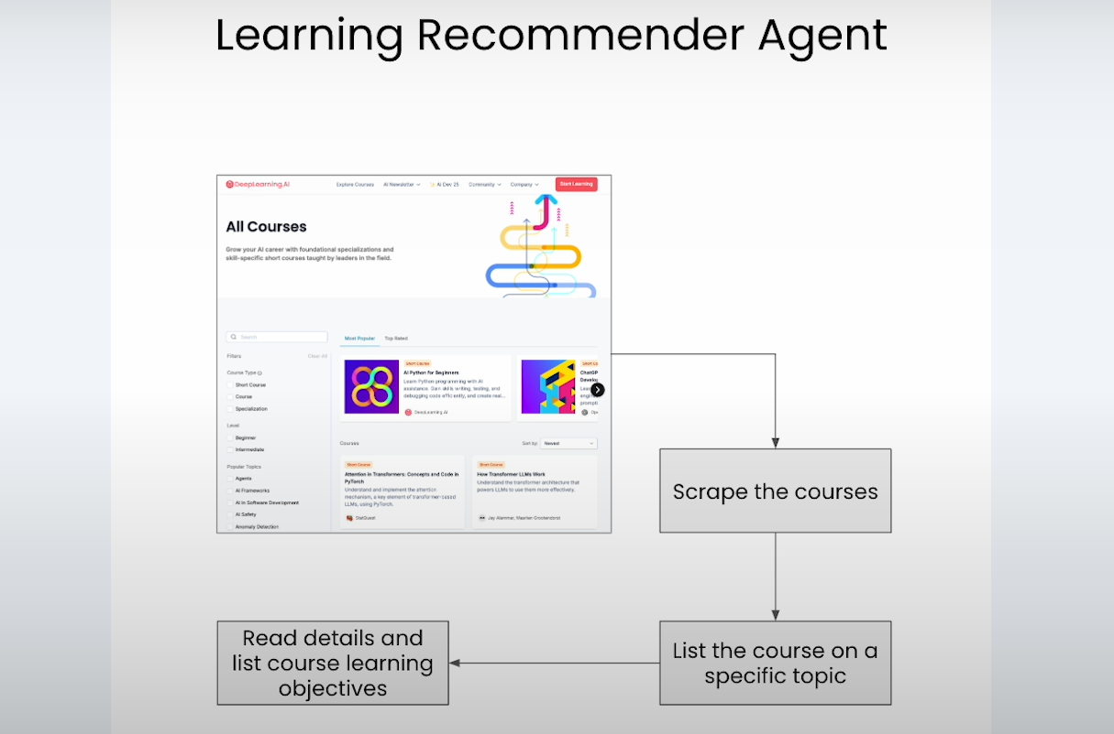

**In this lesson, you’ll build a basic AI-powered web agent that can:**

* **Visit a website (like DeepLearning.AI)**[**DeepLearning.AI - Learning Platform**](https://corporate.deeplearning.ai/courses/building-ai-browser-agents/lesson/wwewm/building-a-simple-web-agent?utm_source=chatgpt.com)
* **Read the page's HTML content**[**DeepLearning.AI - Learning Platform+1DeepLearning.AI - Learning Platform+1**](https://corporate.deeplearning.ai/courses/building-ai-browser-agents/lesson/wwewm/building-a-simple-web-agent?utm_source=chatgpt.com)
* **Extract specific information (e.g., course titles, descriptions, presenters)**[**DeepLearning.AI - Learning Platform**](https://corporate.deeplearning.ai/courses/building-ai-browser-agents/lesson/wwewm/building-a-simple-web-agent?utm_source=chatgpt.com)
* **Present this data in a structured format (like JSON)**

**🧰 Tools and Libraries Used**

**The lesson utilizes the following tools:**

* **Python Libraries: Pandas, Playwright (for browser automation), OpenAI API, and IPython for displaying outputs.**[**DeepLearning.AI - Learning Platform**](https://corporate.deeplearning.ai/courses/building-ai-browser-agents/lesson/wwewm/building-a-simple-web-agent?utm_source=chatgpt.com)
* **OpenAI's Language Model: To process and extract information from the HTML content.**

**🛠️ Step-by-Step Process**

1. **Setup: Import necessary libraries and initialize the OpenAI client with your API key.**[**DeepLearning.AI - Learning Platform**](https://corporate.deeplearning.ai/courses/building-ai-browser-agents/lesson/wwewm/building-a-simple-web-agent?utm_source=chatgpt.com)
2. **Browser Automation: Use Playwright to launch a browser, navigate to the target website, and retrieve the HTML content.**
3. **Data Extraction: Send the HTML content to the OpenAI model with a prompt instructing it to extract specific details (like course information) and return them in JSON format.**[**DeepLearning.AI - Learning Platform**](https://corporate.deeplearning.ai/courses/building-ai-browser-agents/lesson/wwewm/building-a-simple-web-agent?utm_source=chatgpt.com)
4. **Visualization: Use helper functions to display the extracted data in a readable format.**

**1) 🧾 Simple Web Page**

**The lesson begins by selecting a straightforward website—DeepLearning.AI's course page. This site contains a list of courses, each with details like the title, description, presenter, image, and link. The goal is to extract this information automatically.**

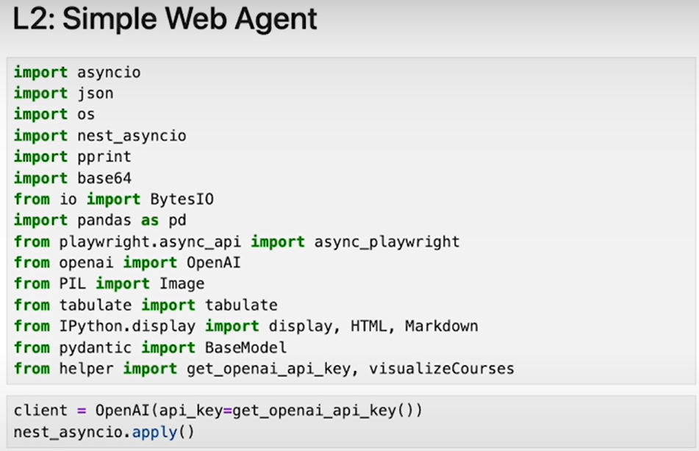

**2) 🤖 Web Scraper Agent**

**A web scraper agent is a program designed to visit websites and collect specific information. In this lesson, the agent is built using Python and tools like Playwright (for browser automation) and OpenAI's language model (to process and understand the webpage content).**

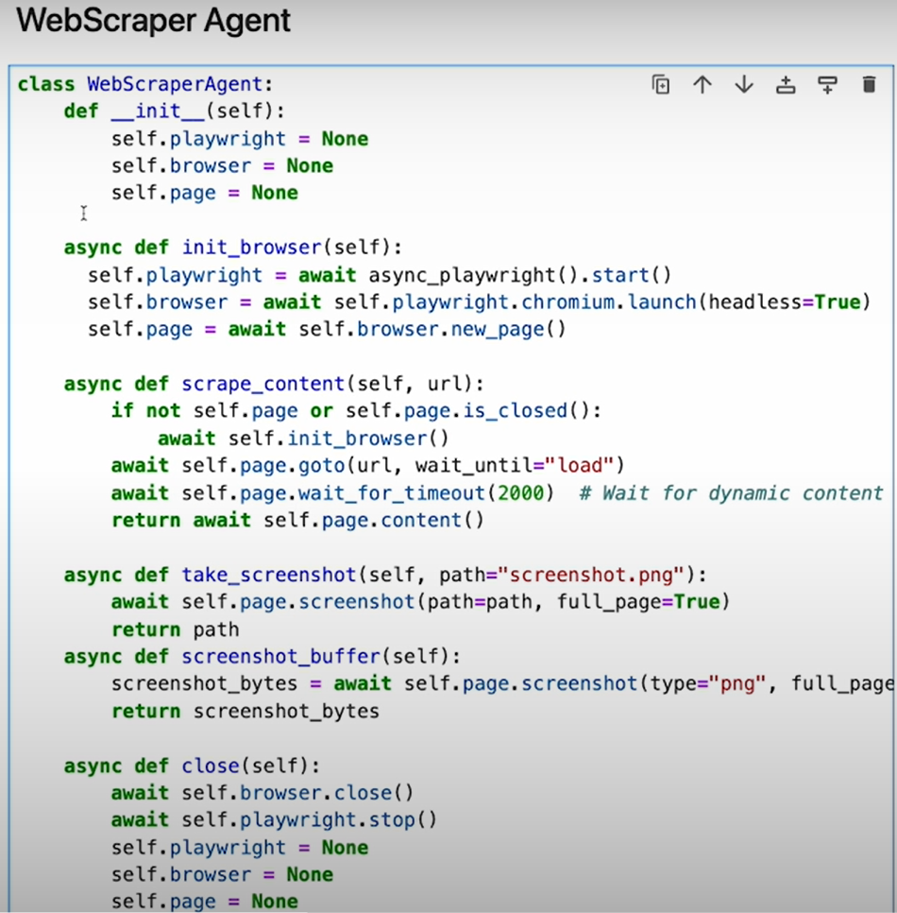

**3) 📊 Structured Data Format**

**Instead of collecting raw, unorganized data, the agent structures the extracted information into a clear format, such as JSON. This format includes fields like:**

* **Title**[**DeepLearning.ai+12Microsoft for Developers+12DeepLearning.AI - Learning Platform+12**](https://devblogs.microsoft.com/semantic-kernel/ai-agents-for-beginners-course-10-lessons-teaching-you-how-to-start-building-ai-agents/?utm_source=chatgpt.com)
* **Description**[**DeepLearning.AI - Learning Platform+9DeepLearning.ai+9DeepLearning.ai+9**](https://www.deeplearning.ai/short-courses/ai-agentic-design-patterns-with-autogen/?utm_source=chatgpt.com)
* **Presenter**[**Microsoft for Developers+7arXiv+7DeepLearning.AI+7**](https://arxiv.org/abs/2410.13825?utm_source=chatgpt.com)
* **Image URL**
* **Course URL**[**DeepLearning.AI+16DeepLearning.AI - Learning Platform+16DeepLearning.AI - Learning Platform+16**](https://corporate.deeplearning.ai/courses/building-ai-browser-agents/community?utm_source=chatgpt.com)

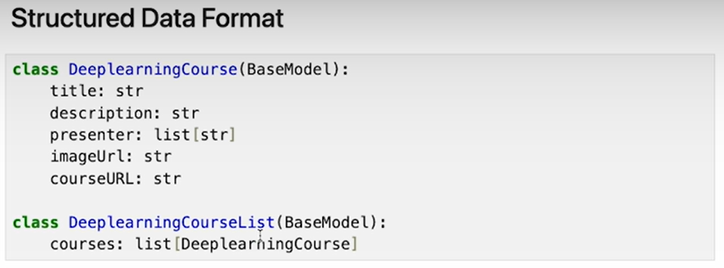

**Structured data makes it easier to use the information in other applications or analyses.**

**4) 🤝 LLM Client for OpenAI**

**An LLM (Large Language Model) client is set up to interact with OpenAI's models. The agent sends the HTML content of the webpage to the model, along with instructions to extract specific information and format it as JSON. This leverages the model's ability to understand and process natural language and HTML structures.**

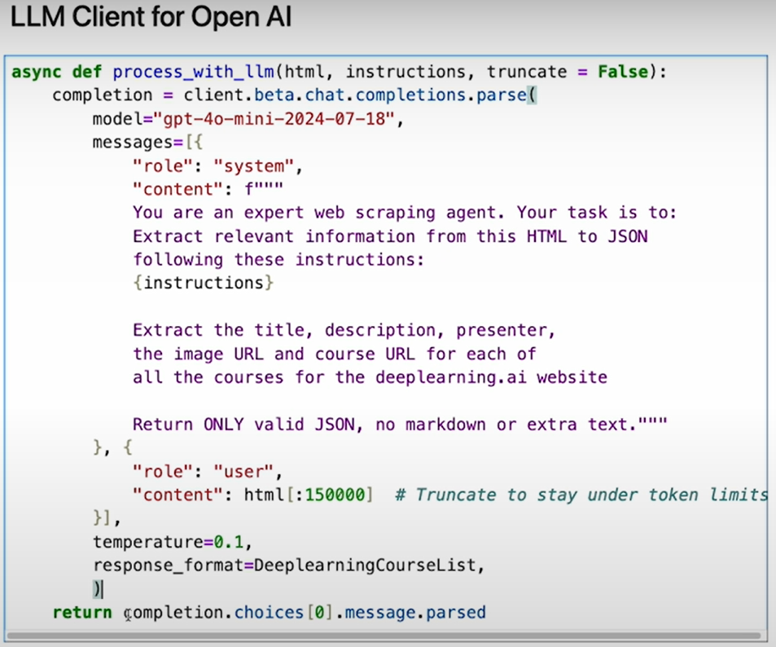

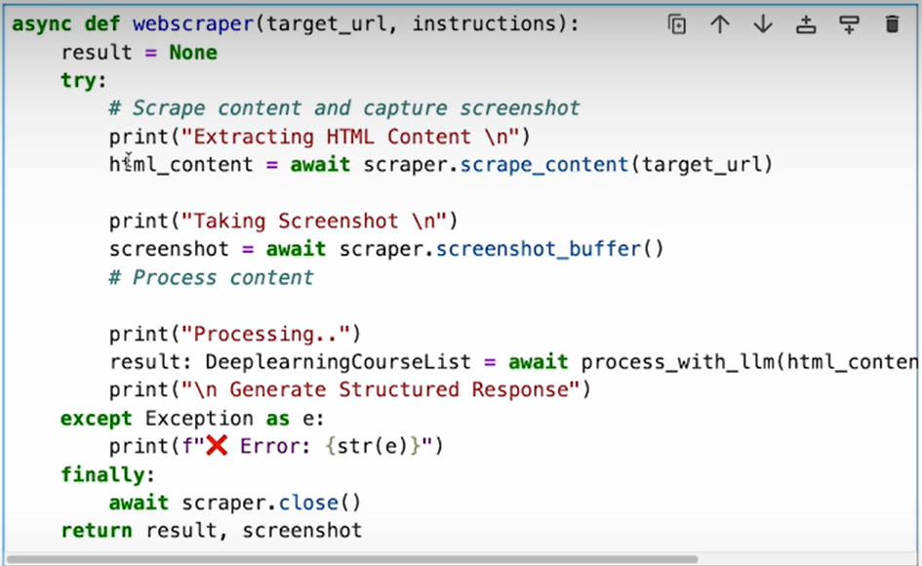

**5) 🧪 Example 1**

**In the first example, the agent is instructed to extract all courses from the DeepLearning.AI website. The process involves:**

* **Navigating to the website**
* **Retrieving the HTML content**
* **Taking a screenshot (for visualization)**
* **Sending the HTML to the OpenAI model with extraction instructions**
* **Receiving structured JSON data with course details**

**The results are then displayed using a helper function that visualizes the courses.**

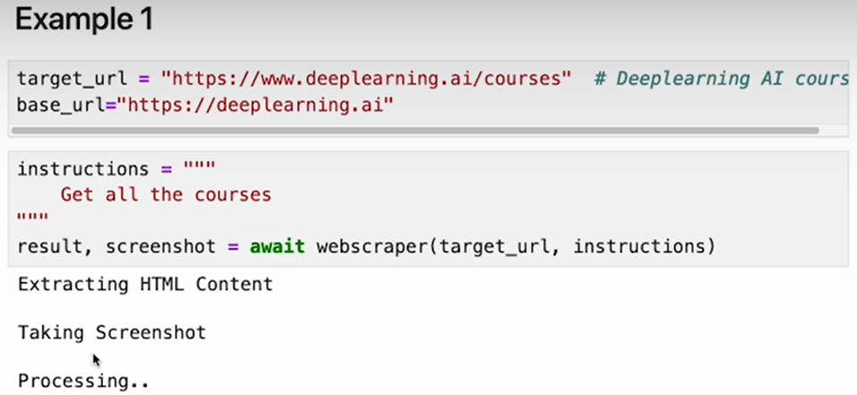

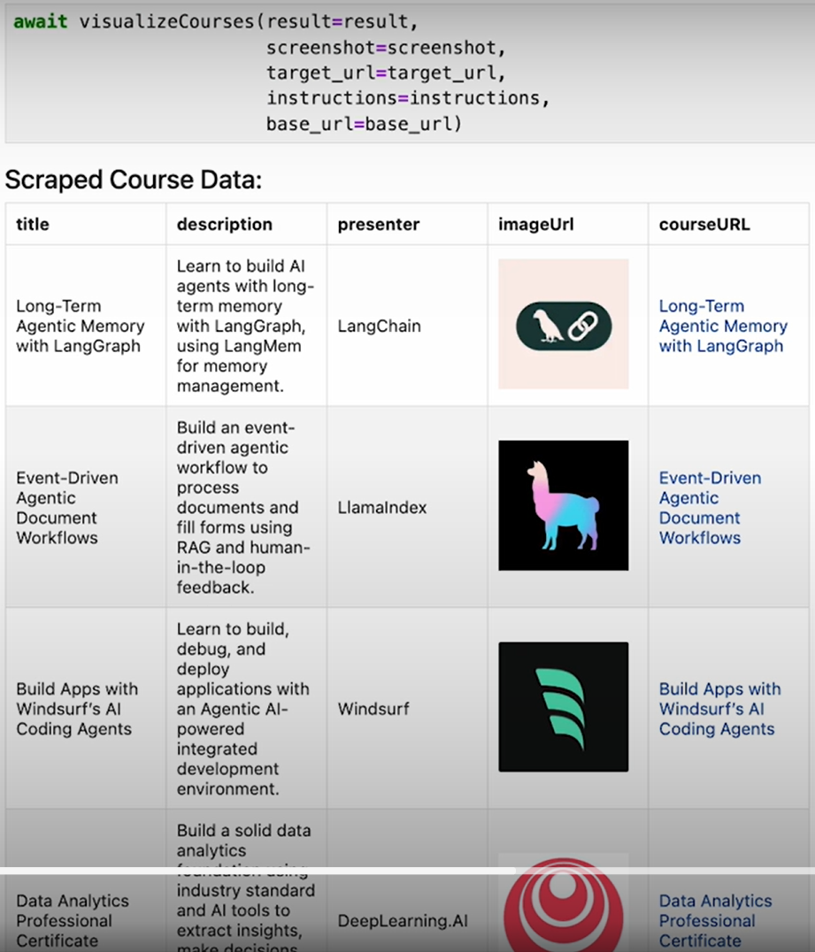

**6) 📚 Example of RAG Courses**

**In another example, the agent is tasked with extracting courses related to "Retrieval-Augmented Generation" (RAG). By modifying the instruction to focus on RAG courses, the agent filters and returns only those courses that match the specified topic. This demonstrates the agent's ability to handle more targeted queries.**

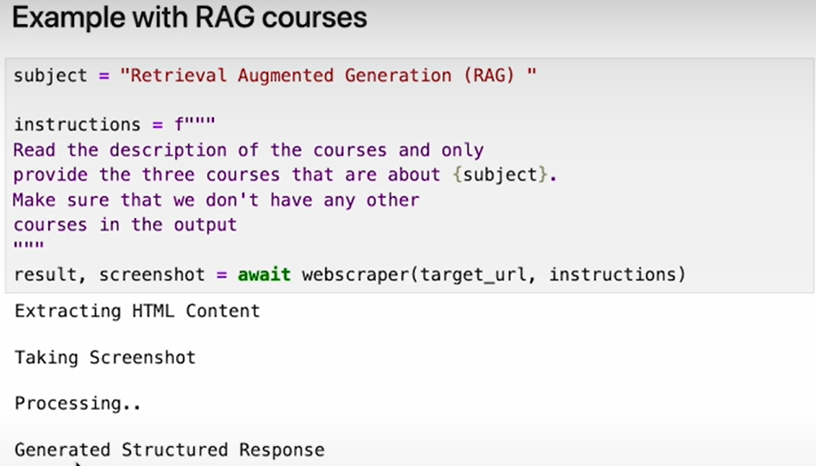

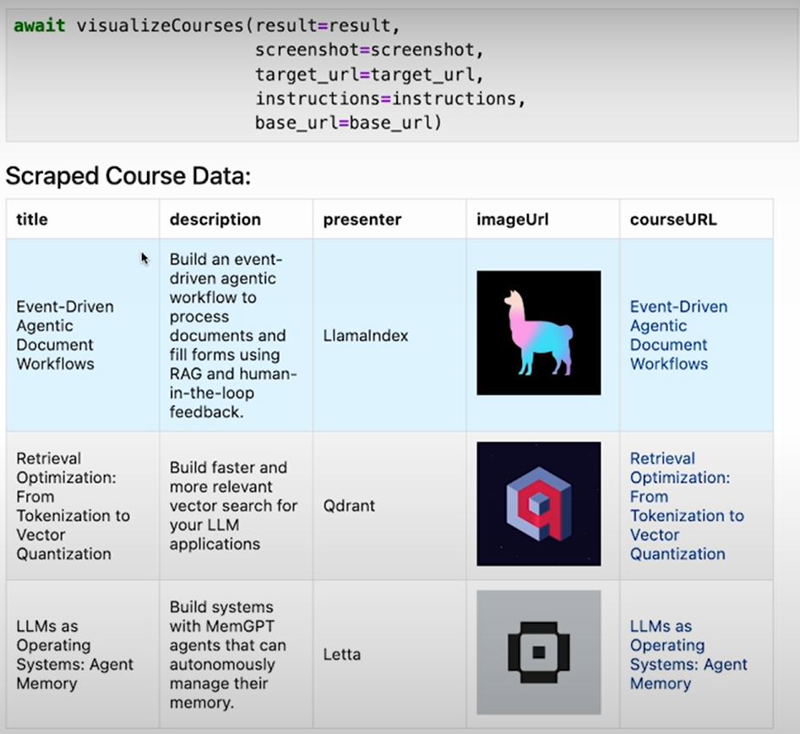

**7) ⚠️ Challenges in Web Agents**

**Building web agents comes with challenges:** [**DeepLearning.AI - Learning Platform+1DeepLearning.AI - Learning Platform+1**](https://learn.deeplearning.ai/courses/building-ai-browser-agents/lesson/znsq5/conclusion?utm_source=chatgpt.com)

* **Dynamic Content: Websites often change, which can break the agent's ability to extract information.**
* **Complex Structures: Some websites have intricate layouts, making it harder for the agent to find the desired data.**
* **Error Handling: The agent needs to manage situations where data is missing or formatted unexpectedly.**

**Addressing these challenges requires robust design and error-handling mechanisms.**

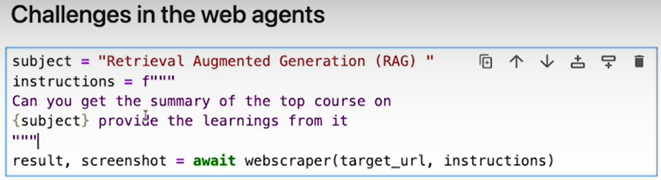

**8) 🧾 Summary**

**This lesson demonstrates how to build a simple AI-powered web agent that can:**

* **Navigate to a website**
* **Extract specific information based on instructions**[**arXiv+15DeepLearning.ai+15DeepLearning.AI - Learning Platform+15**](https://www.deeplearning.ai/short-courses/building-ai-browser-agents/?utm_source=chatgpt.com)
* **Structure the data in a usable format**

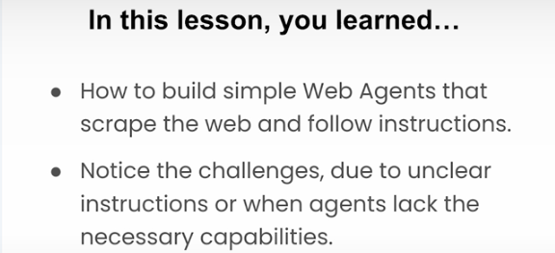

**Building a Simple Web Agent**

**Agent Q**

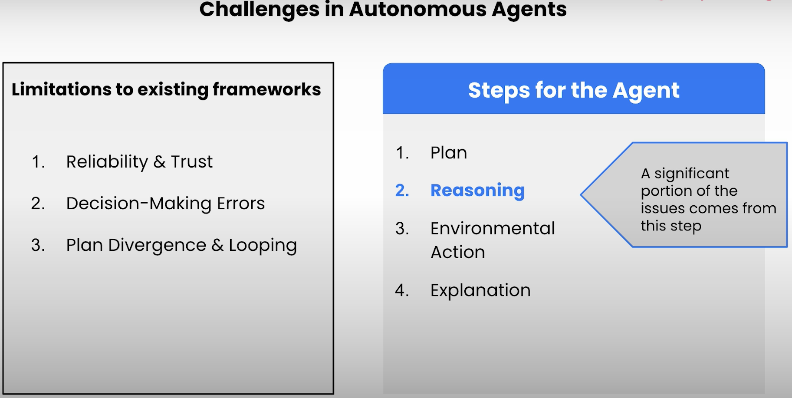

**🧠 00:21 – Challenges in Autonomous Agents**

**Autonomous agents make decisions and perform actions on their own. But they face major issues:**

* **Plan divergence: They may drift away from the original plan if something unexpected happens.**
* **Looping: Agents can get stuck doing the same thing over and over again.**
* **Shallow reasoning: They don’t always think deeply enough to correct mistakes or adapt well.**
* **These errors compound over time, reducing reliability.**

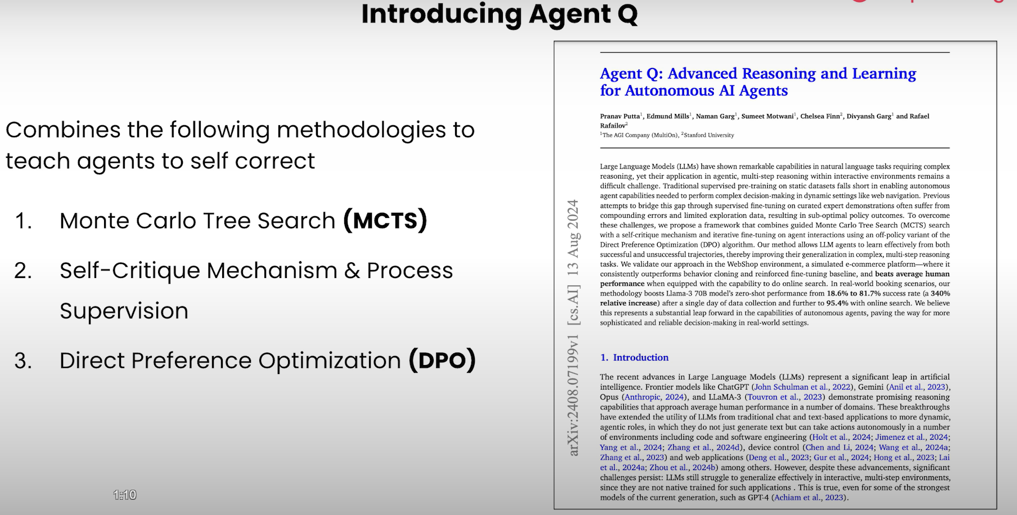

**🤖 What is Agent Q?**

**Agent Q is a smart and powerful AI web agent designed to complete complex tasks on websites—like booking a flight, filling out a form, or applying for a job—all by itself.**

**What makes it special?**

1. **Thinks ahead using Monte Carlo Tree Search — it doesn’t just guess, it simulates different possible actions before picking the best one.**
2. **Checks its own work — it reflects on every step and asks, “Did I do the right thing?”**
3. **Learns from humans — by using human feedback, it keeps getting better at aligning with what users want.**
4. **Avoids common mistakes like getting stuck in loops or forgetting its plan.**

**So, Agent Q is like a thoughtful, self-improving assistant that plans smartly, fixes mistakes on its own, and learns how to do things better over time.**

**🤖 00:50 – Introducing Agent Q**

**To solve these challenges, the video introduces Agent Q. It’s a new kind of web agent built by combining:**

* **Large Language Models (LLMs) with**
* **Better decision-making techniques, including ideas from reinforcement learning.**

**Agent Q is designed to plan better, avoid loops, and improve reasoning when interacting with complex websites.**

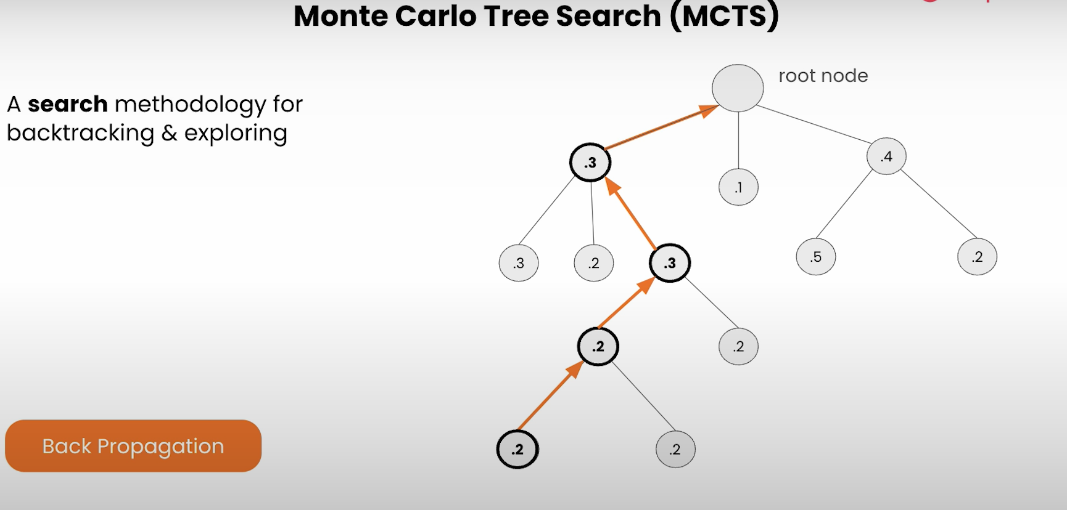

**🌲 01:40 – Monte Carlo Tree Search (MCTS)**

**MCTS is a smart planning algorithm used in games like Chess and Go. In Agent Q, it's used to:**

* **Simulate multiple possible future paths.**
* **Evaluate which sequences of actions are most promising.**
* **Choose the next action based on exploration (trying new things) and exploitation (using what already works).**

**This helps Agent Q reason more deeply and make smarter decisions.**

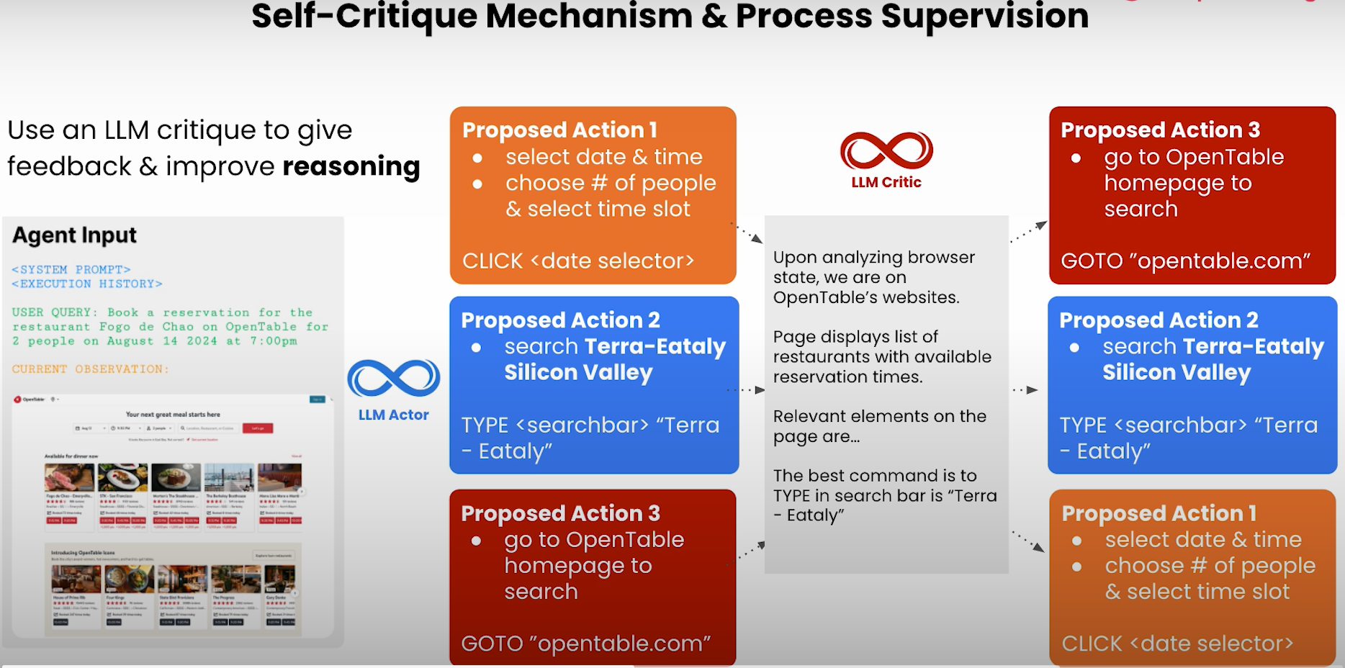

**🪞 03:20 – Self-Critique Mechanism and Process Supervision**

**Agent Q improves by critiquing itself after every major step:**

* **It checks if the last action helped.**
* **If not, it adjusts the plan.**

**This is called process supervision—the agent reflects on its behavior, step-by-step, rather than only focusing on the final outcome. It helps fix mistakes early.**

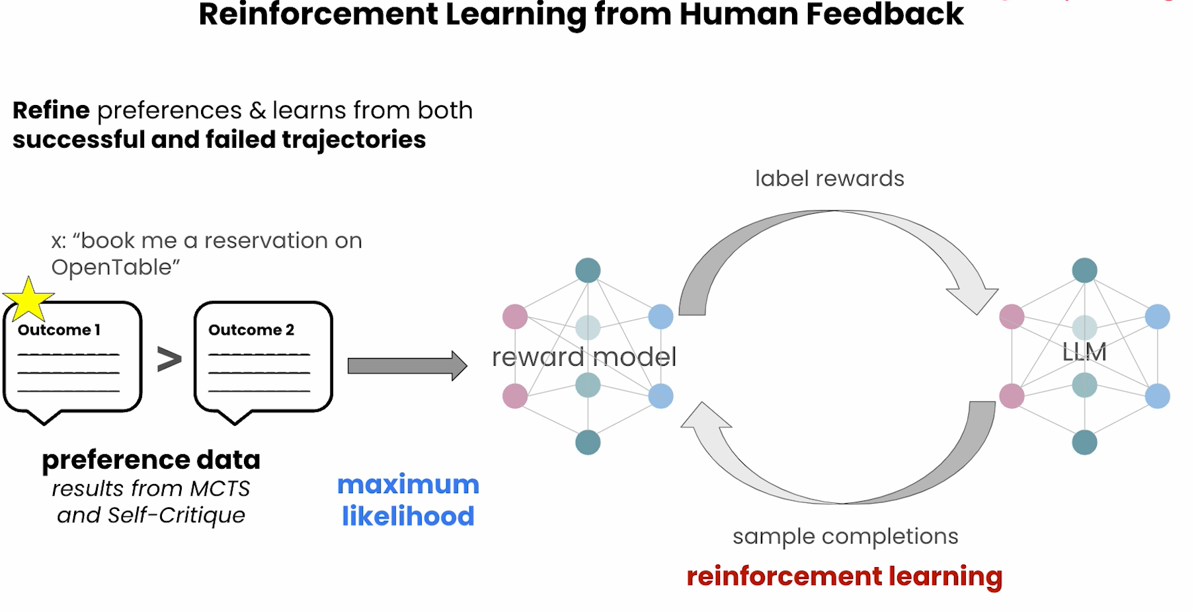

**🧠 04:11 – Reinforcement Learning with Human Feedback (RLHF)**

**This method trains agents based on human preferences:**

* **A human judges which of two outputs is better.**
* **The agent learns from this preference.**

**Agent Q uses this to improve how it solves tasks and handles new challenges, making it behave more helpfully and safely.**

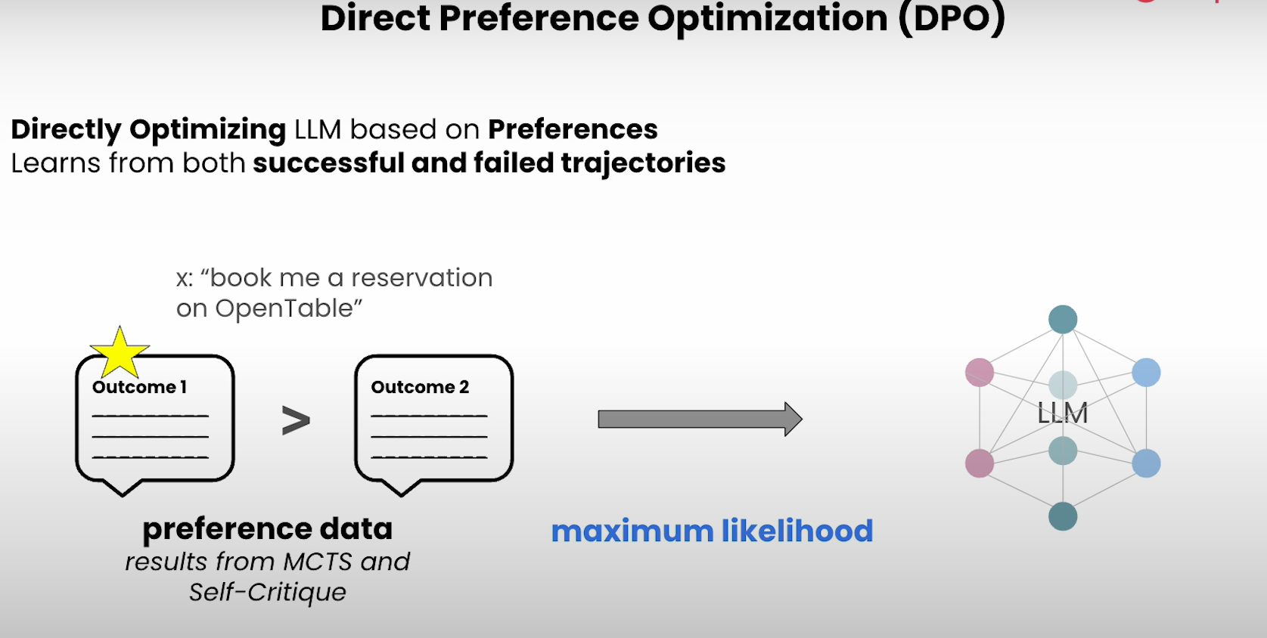

**🧮 05:51 – Direct Preference Optimization (DPO)**

**DPO is an advanced version of RLHF that:**

* **Skips some complex training steps.**
* **Learns directly from human preferences.**

**This allows Agent Q to improve faster and more efficiently than older methods like Proximal Policy Optimization (PPO), while still learning how to act in ways people prefer.**

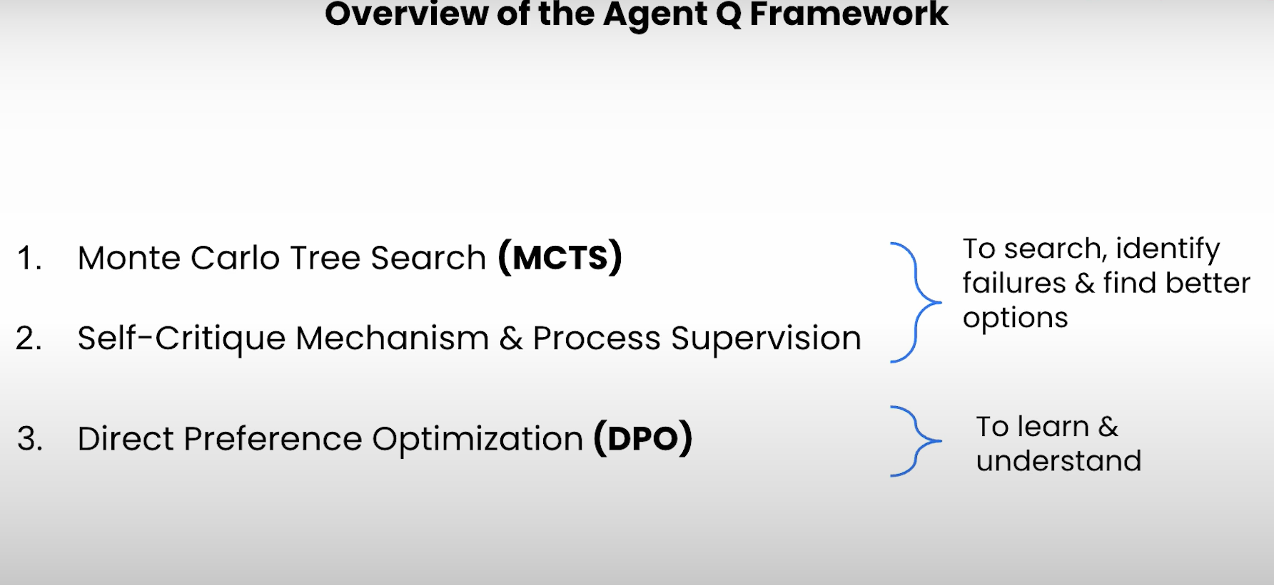

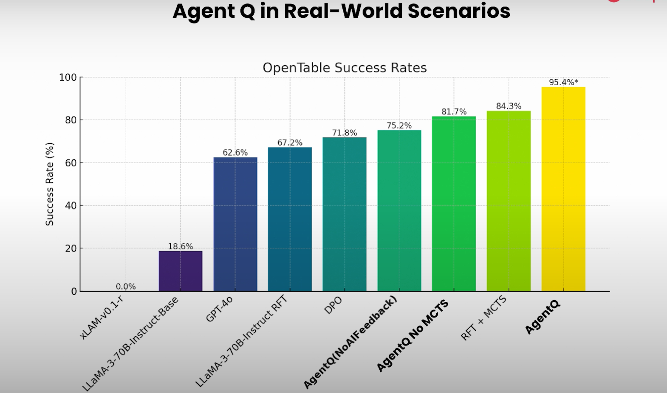

**🧩 06:42 – Overview of Agent Q Framework**

**Agent Q’s full system combines:**

1. **LLMs for understanding and decision-making.**
2. **MCTS for deep planning.**
3. **Self-critique + process supervision for correcting mistakes.**
4. **RLHF or DPO for aligning behavior with human feedback.**

**Future of AI Agents**

**🧠 Key Factors Driving AI Agents Proliferation**

**Explanation:  
AI agents are becoming popular fast. Why? Because of:**

* **Advancements in LLMs (like GPT-4) which can now reason, plan, and take actions.**
* **APIs and web tools that allow agents to do real-world tasks (like booking a ticket or reading emails).**
* **Lower compute costs and better infrastructure (cloud platforms, vector databases).**
* **Growing demand for productivity tools (people want AI assistants to do boring work).**

**👉 In short: Tech is ready, demand is high, so AI agents are exploding in number.**

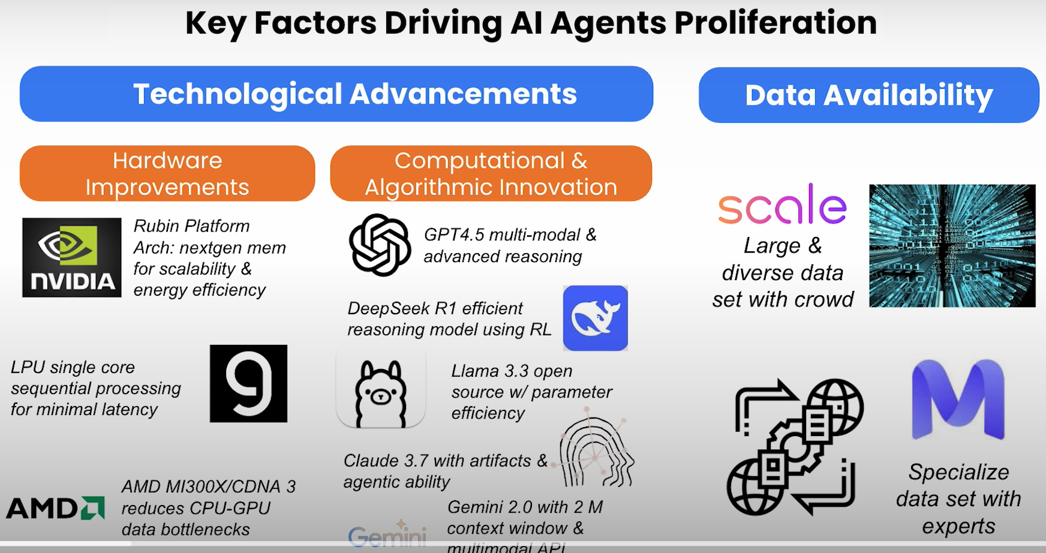

**🌐 00:55 – Web Agents Challenges**

**Explanation:  
Web agents (AI that operates inside browsers to do things like fill out forms, scrape data, click buttons) face many problems:**

* **Webpages constantly change, so it’s hard for agents to keep working reliably.**
* **JavaScript-heavy pages can confuse agents (e.g., dynamic content loading).**
* **Authentication & privacy issues — agents may need passwords, cookies, etc.**
* **Unclear instructions — sometimes humans give vague or incomplete tasks.**

**👉 Bottom line: The web isn’t made for AI agents — yet.**

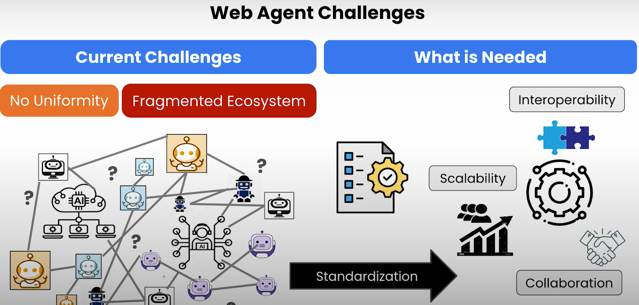

**🛠️ 01:23 – Address Web Agents Issues**

**Explanation:  
To fix these web agent problems, developers are:**

* **Using browser emulators like Puppeteer/Playwright to mimic real humans.**
* **Adding memory and planning ability to agents (so they know what they’ve done).**
* **Creating instruction-following techniques (ReAct, Toolformer, AutoGPT-style).**
* **Designing fallbacks when agents get stuck (like retrying, or asking for help).**

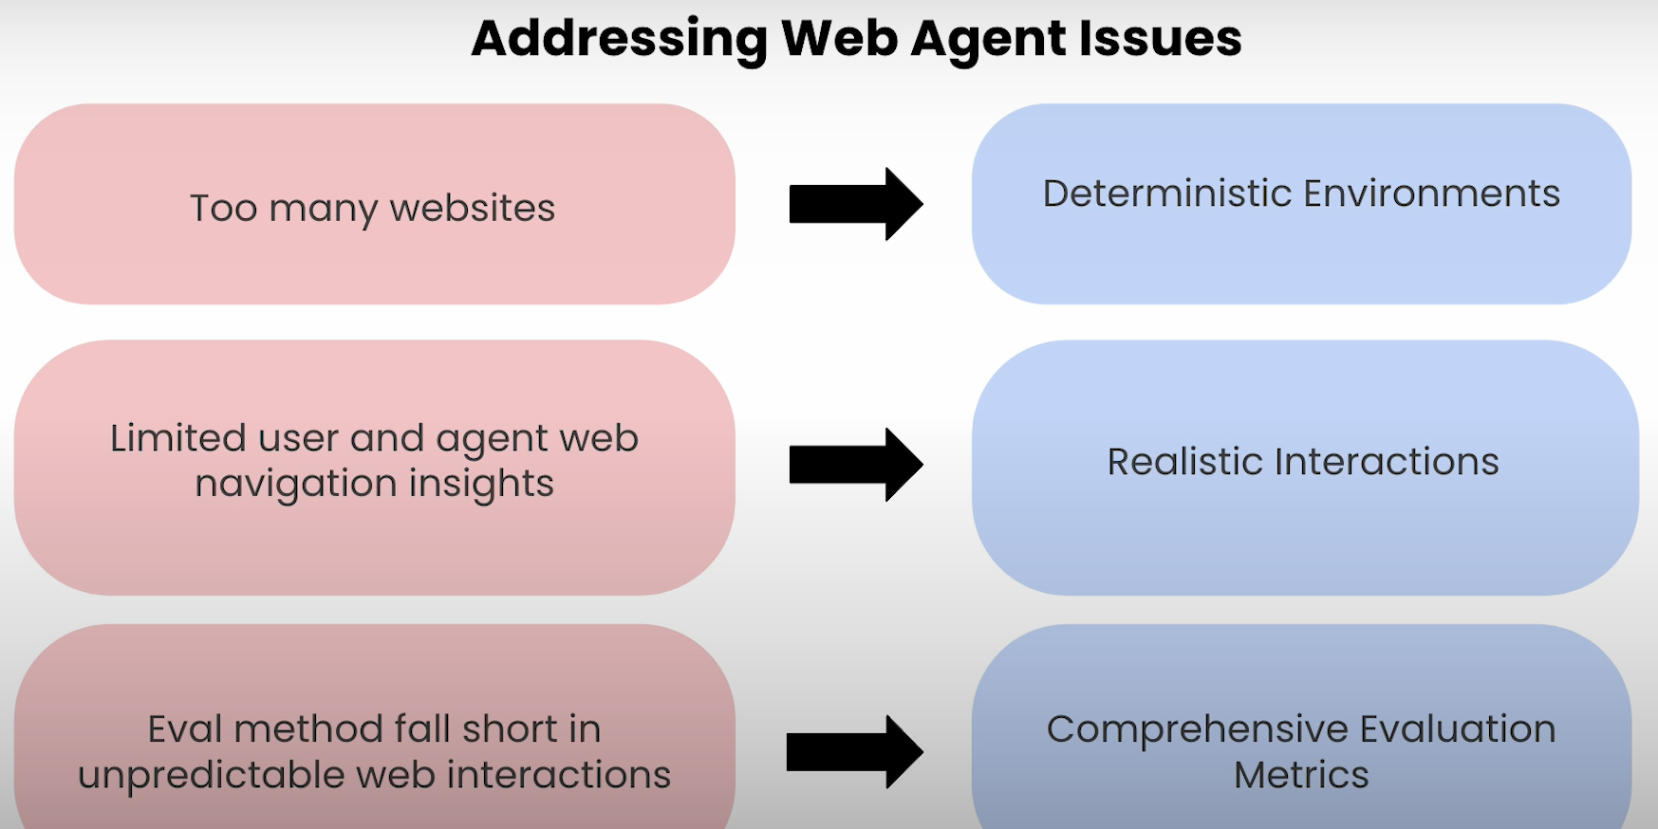

**👉 It's about giving agents more skills to survive in a chaotic, human-made web.**

**📊 02:15 – Benchmarking Web Agents**

**Explanation:  
To measure how smart or reliable a web agent is, researchers are creating:**

* **Standard tasks (like “log in and download a file”).**
* **Evaluation metrics (accuracy, time taken, steps used).**
* **Environments like WebArena or WebShop to test agents.**

**These benchmarks tell us which agents are truly good, and where they struggle.**

**👉 Like how students take exams — agents now take web-based tests.**

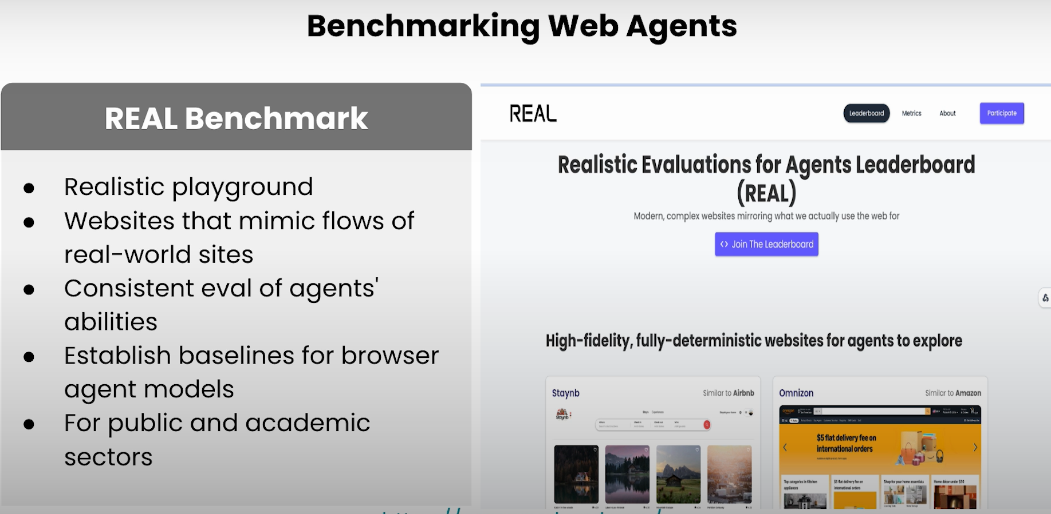

**🤖 03:10 – Multi-Agent Ecosystem Design**

**Explanation:  
Instead of one agent doing everything, we now use multiple specialized agents:**

* **One agent plans.**
* **Another executes.**
* **Another checks if work was done correctly.**

**This mimics how humans work in teams, and helps scale up complexity.**

**👉 Think of it like building an AI “office team” — each agent has a role.**

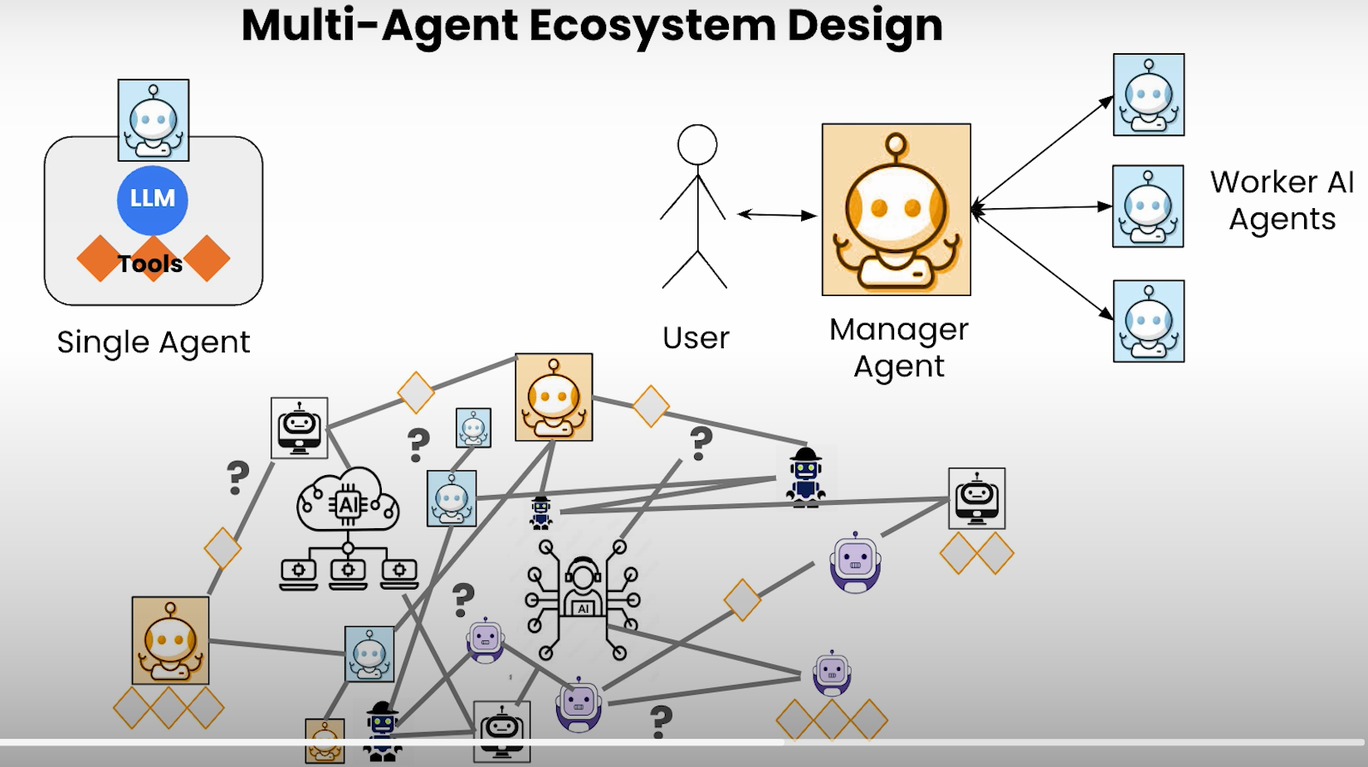

**⚠️ 03:29 – Multi-Agent System Challenges and Design Needs**

**Explanation:  
But building a team of agents is hard:**

* **Coordination is tricky — they must talk to each other properly.**
* **Conflict resolution — what if two agents disagree?**
* **Communication overhead — too much talking can slow things down.**
* **Task division — who does what?**

**👉 You need proper rules, architecture, and protocols like in any human team.**

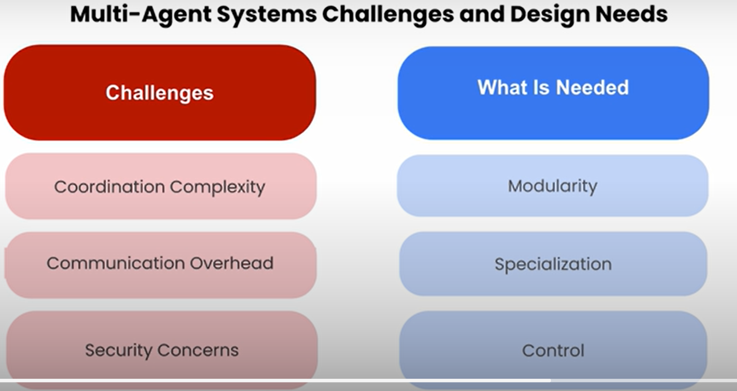

**🏗️ 04:04 – Advancing Architecture for Multi-Agent Systems**

**Explanation:  
To improve multi-agent systems, developers are:**

* **Using shared memory or blackboards — where all agents write and read info.**
* **Introducing planners that break big goals into smaller steps for each agent.**
* **Creating agent hierarchies — like managers and workers.**
* **Designing feedback loops so agents can learn from each other and adapt.**

**👉 Basically, we’re building the infrastructure for intelligent teams of AIs.**

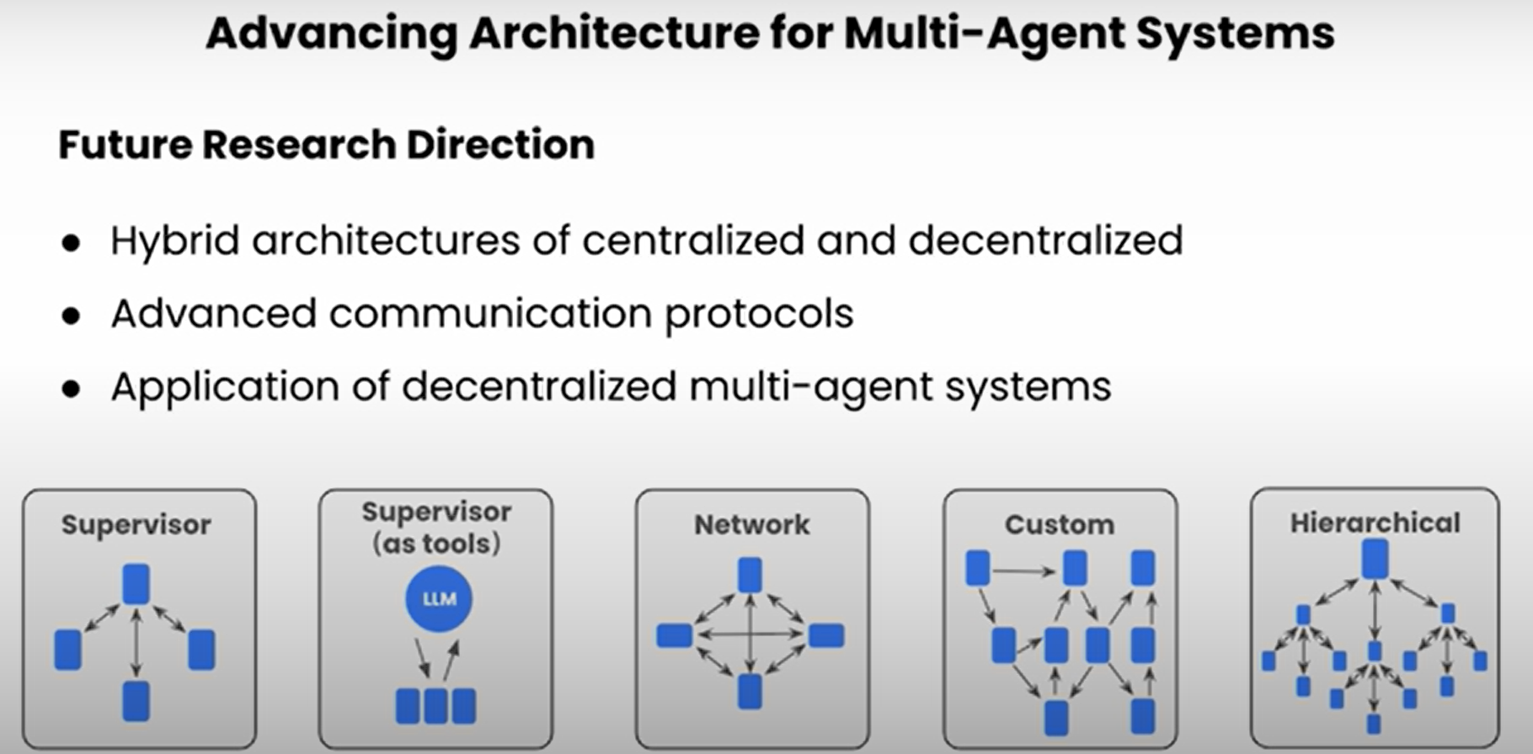

**🔮 04:43 – Future Trends and Direction**

**Explanation:  
The future of AI agents will include:**

* **More autonomy — agents will do tasks with less hand-holding.**
* **Better tools — agents will learn to use software, not just talk.**
* **Personalization — agents will adapt to *you* over time.**
* **Security and ethics — huge focus on safe behavior and trust.**
* **Agent marketplaces — where you can buy/download specialized AI agents (like plugins).**

**👉 The end goal: Your own team of smart, safe, helpful agents doing stuff for you — just like Iron Man's JARVIS 💡**

